TP4: Identification, control and management of scripts
L2 or L3 or tests name: AU-121-05-CSDR Identity and Access Management (IAM), focus: recertification
Legal entities in scope: DBAG/CBL/ECAG/CBF/CH/LuxCSD/CS/CI/CFCL/ExR/EFAG

TP4: Audit the identification, control and limitation of scripts with power user rights (follow up on FuN 250714112849).

- Test if FuN 250714112849 has any substance.
- Verify if scripts/ shells with enhanced rights (to e.g. change or reactivate accounts) are considered in regulation or external demand. Test if a regulatory request demands specific handling of automated activities (e.g. change or reactivate accounts).
- Verify if and how these scripts are defined and controlled according to the 1LoD and 2LoD documentation.
- Test the execution and reporting focusing scripts with enhanced rights to e.g. change or reactivate accounts.
- Test (follow up on FuN 250722123256) if locked CMAX-database level users are deleted in September recertification.

Related risks, ref BCA:
An incomplete, incorrect or uncontrolled recertification process may lead to the following risks:
- Unauthorized access
- Regulatory incompliance
- Violation of Segregation of Duties (SoD), and least privilege principle
- Issues with data integrity
- Insider threats (e.g. data theft, sabotage, misuse of privileges).

Related FuN #250714112849
In conjunction with the audit finding 2025-019_F04-A01, clarify and ensure that such a clean-up is performed on all production databases. Apparntley the obsolete database users cannot be removed ad-hoc and can only be done following a Condor ticket (in our case Ticket 247681) and a validation in the next possible release.
Responsibility is with Carsten Kreuz’s team, namely Florian Laudensack.

Also in relation to this finding, the application owner decided to lock all the 119 users so no one could use them until the final deletion. However, the the user were locked by the DBA, a script running daily called SQLCQR activated 6 of the 119 users. The rational is unknown. We should check:
- is there a list of such powerful script, which can overright users accesses, change passwords, lock or unlock users
- who owns it?
- why isn´t the application owner aware of such script performing actions on his application?
- how is this controlled?

This has the attetion of Volker Riebesell, Daniel Besse and Yannick Goineau
------------------
Related FuN #250722123256
In relation to the closure request 2025-019_F04-A01, as a first step, users were locked to minimize the risk and allow the closure.
The final deletion is expect during the September release. This activity can only be done by the privilegd DBAs.
In the audit, the full deletion of the locked users on the CMAX database level should be confirmed.
------------------

TP4.1 Test if FuN #250714112849 has any substance

Testing:
Meeting on FuNs:
To: Frank Ackermann; Gil Strahl; Aleksandra Galaganova; Milos Medrik
Subject: 2025-067 IAM and PAM // Exchange on FuN #250714112849 and #250722123256
When: Montag, 13. Oktober 2025 13:00-13:25

In the meeting the circumstances on how finding 2025-019_F04-A01 was closed, was explained. This relates also to FuN #250722123256 .
The testing is not specifically part of IAM/PAM and account-recertification because technical users and database users are not managed with IIQ and Nexis.

Nevertheless further testings will be performed to verify, if the 119 disabled users are removed in the September release. See TP4.6 .

TP4.1 Outcome/ Conclusion
No observations. Testing in TP4.6 .

TP4.2 Verify if scripts/ shells with enhanced rights (to e.g. change or reactivate accounts) are considered in regulation or external demand. Test if a regulatory request demands specific handling of automated activities (e.g. change or reactivate accounts)

Testing:
The following regulations were checked, if and how technical regulations exits on automated add, removal or change activities of accounts.

DORA Main
(REGULATION (EU) 2022/2554 OF THE EUROPEAN PARLIAMENT AND OF THE COUNCIL of 14 December 2022 on digital operational resilience for the financial sector and amending Regulations (EC) No 1060/2009, (EU) No 648/2012, (EU) No 600/2014, (EU) No 909/2014 and (EU) 2016/1011)

DORA RTS Risk Management
(COMMISSION DELEGATED REGULATION (EU) 2024/1774
of 13 March 2024 supplementing Regulation (EU) 2022/2554 of the European Parliament and of the Council with regard to regulatory technical standards specifying ICT risk management tools, methods, processes, and policies and the simplified ICT risk management framework

EBA Guidelines on ICT and security risk management
(EBA/GL/2019/04, 28 November 2019)

CSSF
(Circular CSSF 20/750, REQUIREMENTS REGARDINGINFORMATION AND COMMUNICATION TECHNOLOGY (ICT) AND SECURITY RISKMANAGEMENT)

TP4.2 Outcome/ Conclusion
None of the regulations request a specific control or management on automated scripts.

To be discussed with Milos!

TP4.3 Test if controls are defined and operated to identify user-access or role changes based on scripts

TP4.3 Outcome/ Conclusion

TP4.4 Verify if and how these scripts are defined and controlled according to the 1LoD and 2LoD documentation.

TP4.4 Outcome/ Conclusion

TP4.5 Test the execution and reporting focusing scripts with enhanced rights to e.g. change or reactivate accounts.

TP4.5 Outcome/ Conclusion

TP4.6 Test (follow up on FuN 250722123256) if locked CMAX-database level users are deleted in September recertification.
Testing:
To: Frank Ackermann; Stephane Jantzen; Tibor Szabo; Joel Sanson; Gil Strahl; Milos Medrik
Subject: RE: 2025-067 IAM and PAM // follow-up on Sept release CmaX (2025-019_F04-A01)
When: Mittwoch, 22. Oktober 2025 09:45-10:00

In the meeting it was explained that heritage users were setup with personal accounts (AB123) in the database. This was done because IIQ was not in place.
In time of the migration, the users were deactivated to avoid further changes or corruptions.
IIQ ran a script which replayed the reconciliation information from IIQ to CmaX-database; and therefore
re-actived the users.

After closing the finding, the users were deleted in the Sept release.
See EVIDENCE on latest user-list (-> users were deleted).

TP4.6 Outcome/ Conclusion
No deviation to be described. Users were deleted.
FuN 250722123256 can be closed.

Outcome/ Conclusion TP4

XXX BELOW IS READY XXX Workpaper IAM Recertification Processes - Overview
L2 or L3 or tests name: AU-121-05-CSDR Identity and Access Management (IAM), focus: recertification
Legal entities in scope: DBAG/CBL/ECAG/CBF/CH/LuxCSD/CS/CI/CFCL/ExR/EFAG

Test(s) according to RCA:
- TP1: Verify internal and external demands, management, oversight, metrics, measurement, and reporting of
- TP2: Test IIQ-onboarding, on-prem and cloud (follow up FuN 241106111950, reference to #2023-043_F11).
- TP3: Audit recertification of SharePoint access and accounts outside DBG domain accounts (follow up FuN
- TP4: Audit the identification, control and limitation of scripts with power user rights (follow up on FuN 250714112849).
- TP5: Assess recertification of centralized business roles in Nexis, carried out in 2025 (ref. L2 AU-110-11-Business Roles)
- If applicable and not overlapping with ongoing remediation:
TP6: Audit the oversight and recertification for birthright roles (reference to #2025-024_F03).

Proposal for sample-testing, ref. to PAM implementation testing:
Proposal for sample-testing, ref. FuN 250306153041 (see testing PAM implementation):
Check the April 2025 IIQ recertification campaign for CyberArk C safe access groups

Risk:
An incomplete, incorrect or uncontrolled recertification process may lead to the following risks:
- Unauthorized access
- Regulatory incompliance
- Violation of Segregation of Duties (SoD), and least privilege principle
- Issues with data integrity
- Insider threats (e.g. data theft, sabotage, misuse of privileges).

Procedures / Criteria / documents used:

2LoD: Identity and Access Management Guideline Version, V1.1, 15.08.2025 LINK

1LoD: Identity and Access Management Procedure, V1.0, 30.06.2025 LINK

Control design effectiveness
- Review XXX.
Control operating effectiveness
- Review XXX.

Conclusion: OK/issue for close-out list
- Issue 1: Weakness in XXX

- Issue 2: Lack of XXX

Audit procedures/source:
Internal audit (initials of auditors) has performed the following Audit procedures:
- Inquiry: Held interviews with responsible stakeholders
- John Doe – Corporate XX (XXX) – Deputy Head of Unit
- Jane doe – Head of Section – XXX
- Inspection: Of policies and evidences
- Sampling for both location (Reviewed 100% population)

Procedures / Criteria / documents used
- Corporate Security Policy
- Internal Control System Policy
- Corporate Security Standards
- Risk Assessment Procedure

TP1: Recertification: Demand Management, Controlling, Reporting
L2 or L3 or tests name: AU-121-05-CSDR Identity and Access Management (IAM), focus: recertification
Legal entities in scope: DBAG/CBL/ECAG/CBF/CH/LuxCSD/CS/CI/CFCL/ExR/EFAG

TP1: Verify internal and external demands, management, oversight, metrics, measurement, and reporting of IAM recertification.
- Verification of demands and metrics regarding recertification
- Identification of demands and metrics in 1LoD and 2LoD documents, procedures, and controls
- Verification of reporting and control results

Related risks, ref BCA:
An incomplete, incorrect or uncontrolled recertification process may lead to the following risks:
- Unauthorized access
- Regulatory incompliance
- Violation of Segregation of Duties (SoD), and least privilege principle
- Issues with data integrity
- Insider threats (e.g. data theft, sabotage, misuse of privileges).

TP1.1 Verification of demands and metrics regarding recertification
Testing:
Internal Audit identified the following underlying for recertification of accounts:

2LoD: Identity and Access Management Guideline Version, V1.1, 15.08.2025 LINK
ID: 15 (version 1.1) Recertification 15
The recertification of access rights and role compositions must be defined, integrated in the access procedure, monitored and controlled.
15.1 The following types of recertification must be performed and documented:
15.1.1 User access recertification must take place every 6 months for business-critical access and for privileged access of all levels by the responsible Line Manager and respective Role Owners.
15.1.2 User access recertification must take place every 12 months for all other accesses by the responsible Line Manager.
15.1.3 The following types of recertification must be performed and documented:
Role composition recertification by the Role Owner and Asset Owner must take place every 12 months and must include birth right roles.
15.2 All unauthorized access, which has been identified during the recertification process, must be revoked after the recertifier’s sign-off.
15.3 Dedicated access to legal entity data must be reviewed at least once every 12 months by an employee of the respective legal entity.
(ref. DORA RTS RMF A.21.1e.iv), ISO/IEC 27001:2022 A.5.18)

- Reason why “business critical” are in focus, see TP 1.X and TP 1.XX

DORA, RTS ICT Risk Management, 2024/1774, Article 21, Access control
(e) account management procedures to grant, change or revoke access rights for user and generic accounts, including generic administrator accounts, including provision on all of the following:
(i) assignment of roles and responsibilities for granting, reviewing, and revoking access rights;
(iii) withdrawal of access rights without undue delay upon termination of the employment or when the access is no longer necessary;
(iv)update of access rights where changes are necessary and at least once a year for all ICT systems, other than ICT systems supporting critical or important functions and at least every 6 months for ICT systems supporting critical or important functions;

According to Identity and Access Management Procedure Version 1.0 30.06.2025 Page 94 of 112, chapter 4.11.1.2. Business-critical:
“The criticality of an IT asset is determined by its information classification rating, encompassing factors like confidentiality, integrity, authenticity, and availability.”
“When an access right on an IT asset permits access to critical data, functions, or the manipulation of such data related to any of its information attributes, this access must be designated as business-critical access in the corresponding Authorization Concept.” This applies to access to all critical data and/or functions regardless of the IT asset’s classification (e.g., access to sensitive data on a major-rated IT asset).”
“Assigning business-critical access requires approval from both the Role Owner and the Line Manager.”
4.11.1. Access Types
“Business-critical access: This is a subset of business access, required for non-administrative tasks involving sensitive data or functions with restricted access.”

According to DORA (RTS Riskmanagement, OJ L, 25.6.2024, Art 21 e)
(e) account management procedures to grant, change or revoke access rights for user and generic accounts, including generic administrator accounts, including provision on all of the following:
- assignment of roles and responsibilities for granting, reviewing, and revoking access rights;
- (iv) update of access rights where changes are necessary and at least once a year for all ICT systems, other than ICT systems supporting critical or important functions and at least every 6 months for ICT systems supporting critical or important functions;

According to CSSF (Circular CSSF 20/750) and EBA
3.4.2. Logical security
31 (f) Access recertification: access rights should be periodically reviewed to ensure that users do not possess excessive privileges and that access rights are withdrawn when no longer required.

TP1.1 Outcome/ Conclusion
The definition in DBGs written rule meet the regulatory requirement.
No deviation to be described.

TP1.2 Identification of demands and metrics in 1LoD and 2LoD documents, procedures, and controls
See in TP1.1
2LoD: Identity and Access Management Guideline Version, V1.1, 15.08.2025 LINK
DORA, RTS ICT Risk Management, 2024/1774, Article 21, Access control
CSSF (Circular CSSF 20/750) and EBA, 3.4.2. Logical security

The 2LoD Guideline sets correctly the demand, which reflects the recertification frequence (annually, and for CIF/critical roles half-annually).
The 1LoD Identity and Access Management Procedure, Version: 1.0, 30.06.2025, explains the demands in more detail and lays out the 1LoD process in chapter 3.1.12. Recertification – ID 15 .

Testing:
Analysis of the underlying documentation and requirements.

The Procedure does not define 1LoD controls and control criteria. This results in missing KPIs and specific oversight over the recertification.

The Procedure states in several segments “If this control measure cannot be established due to technical limitations and/or organizational feasibility, a risk registry entry must be created and sent for review in accordance with the ICT Risk Management Guideline (see chapter 4.12).”

Testing:
Risk entries in ISCRA:

IA developed Search Query 1:
text ~ "Lack of, or insufficient processes for user access management" AND type = Risk AND status != closed
LINK

IA developed Search Query 2:
text ~ "IIQ onboarding" AND type = Risk AND status != closed
LINK

Cross-Analyzing the APMS-export with the ISCRA-risk entries.
FILE

With the testing Internal Audit identified, that for some Applications with an unknown IIQ-onboarding status no risks were raised (referring the onboarding status).
Some of these applications have not an Digitized Authorization Concept yet (version 1 = initial unfilled template).

According to IT Core Process Governance (U), the performed ITAM-042 control is to identify empty field in the onboarding status. The ITAM-042 control is performed twice a year.
ITAM-023 control performed on monthly basis checks the completeness of mandatory attributes in APMS.
ITAM-025 control performed twice a year checks completeness and correctness of data in APMS by collecting data confirmation from Application Owners.

TP1.2 Outcome/ Conclusion
Specific ITAM-controls on onboarding could not be identified. Due to non-existing of controls, legal demands and metrics could not be considered.

TP1.3 Verification of reporting and control results
As described, in TP1.1 and TP1.2, KPIs are not defined as such.

Statement in email on Access Certification KPIs:
“From our perspective, defining KPIs for certification completion is not meaningful, as the process is inherently self-enforcing. If a certification is not completed within the defined timeframe, access is automatically revoked. This mechanism ensures that decision-makers are compelled to act, as failure to do so may result in users losing access to resources critical to their business operations.
Nevertheless, we do monitor the percentage of completed decisions during certification campaigns. In recent cycles, completion rates have consistently exceeded 95%. While one could argue that a KPI target should be set, we believe the only acceptable target is 100%, as every decision-maker is expected to fulfill their responsibility. To mitigate potential business impact, we proactively reach out to decision-makers toward the end of the certification period—beyond system notifications—to remind them of pending actions. This is not part of a formal process but rather a preventive measure.”

As stated, ICA did not define KPIs and did not proactively measure the status of recertification. Consequently, respective monitoring was not established.
According to the email August 15, 2025 6:01:16 AM, KPIs were not defined and respective reporting was not established.

The IIQ-onboarding status is continuously monitored and reported.
See slides Digital Security Committee, Group Security, June 2025 .

Access Control Management reports on
- IIQ onboarding (Applications)
- IIQ onboarding (Infrastructure)
- Segregation of Duties (Application)

A reporting on
- Recertification of User Access
- Recertification of Roles
is not performed.

Information from Meeting:
To: Frank Ackermann; Carsten Kreuz; Aamir Maliyakal; Stephan Hampel; Florian Laudensack
Subject: 2025-067 IAM and PAM // walkthrough open questions
When: Donnerstag, 9. Oktober 2025 13:00-13:55
- The monthly application numbers are from APMS / CMS
- The numbers vary due to information in APMS / CMS are always edited (e.g.
- ICA is overseeing the risks raised in ISCRA, but do not further process them (see other TP)
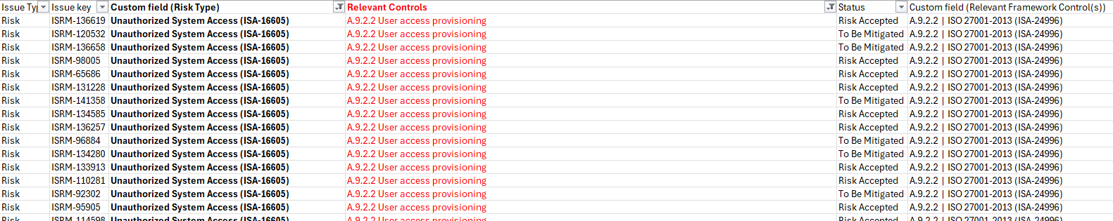
- Controls are not defined.

TP1.3 Outcome/ Conclusion
Internal Audit noted, that reporting, e.g. to the GSC, on
• Recertification of User Access
• Recertification of Roles
is not performed.

In course of the development of the report, the outstanding oversight and reporting is evaluated.

TP 1.X – Business Critical labeling
Not part of the original testing-plan (BCA / RCA) but identified during the fieldwork.

Testing:
According to Identity and Access Management Procedure Version 1.0 30.06.2025 Page 94 of 112, chapter 4.11.1.2. Business-critical:
“The criticality of an IT asset is determined by its information classification rating, encompassing factors like confidentiality, integrity, authenticity, and availability.”
“When an access right on an IT asset permits access to critical data, functions, or the manipulation of such data related to any of its information attributes, this access must be designated as business-critical access in the corresponding Authorization Concept.” This applies to access to all critical data and/or functions regardless of the IT asset’s classification (e.g., access to sensitive data on a major-rated IT asset).”
“Assigning business-critical access requires approval from both the Role Owner and the Line Manager.”
4.11.1. Access Types
“Business-critical access: This is a subset of business access, required for non-administrative tasks involving sensitive data or functions with restricted access.”

According to the Identity and Access Management Guideline, V1.1 15.08.2025, Business-critical access is defined as:

“Business-Critical Access (BCA) is considered non-privileged access to IT Applications3 that supports critical or important functions.*
For the avoidance of doubt: This Guideline shall not comprise requirements for the processing of individual’s personal data as such legal requirements are already reflected in the Data Protection Policy or similar legal entity related/associated documentation.”
* Please refer to the CIF Identification Procedure of the Written Rules Database on the intranet for further details.

In course of the verification in IIQ and Nexis, deviations and empty fields were identified. These has been discussed and communicated to the auditee:

Email, Friday, October 24, 2025 2:56 PM
To: Carsten Kreuz <carsten.kreuz@deutsche-boerse.com>; Stephan Hampel <stephan.hampel@deutsche-boerse.com>
Cc: Milos Medrik <milos.medrik@clearstream.com>; Aamir Maliyakal <Aamir.Maliyakal@deutsche-boerse.com>; Srinivas Rampalli <srinivas.rampalli@eurex.com>; Shravankumar Mohankumar <shravankumar.mohankumar@deutsche-boerse.com>
Subject: RE: 2025-067 IAM and PAM // summary of observations, focus on (business) criticality

- Role-Information in IIQ (label “Critical”) can be selected as true or false.
As of today (24.10.2025) 184.575 roles were selected critical: true, 3.733 roles were selected critical: false or empty.
- Role-Information in Nexis (label “DBG Critical”) can be selected as true or false.
As of today (24.10.2025) 184.245 Business roles were selected critical: true, 4.109 were selected critical: false and 2.062 were selected critical: empty.
- Employee-Information in Nexis (label “Criticality”) can be selected as low, medium, high, very high.
As of today (24.10.2025) 13.468 employees were selected with medium.
- Entitlement-Information in Nexis (label “Criticality”) can be selected as low, medium, high, very high -AND- (label “DBG Critical”) can be selected as true or false.
As of today (24.10.2025) 80.094 entitlements were without a DBG Critical label (empty) and 150.796 were selected as true.
- According to the IAM for Digital Authorization Concepts (V0.12, 25.04.2025, 13.2 Validation rules) , (Business)Criticality is a mandatory field for entitlements. An unselected label (empty) was not defined as false.
- The Application Owner set the business criticality of the IT role. A definition for label “DBG Critical” is outstanding.
- A definition for label “Criticality” and its usage (e.g. for the process and latter controls) is outstanding.
- The criticality-selection “DBG Critical” adjudicates on if the recertification is performed half-annually or annually (including review of access requests and involvement of role owner).
- The information on the selected CIAA-criticality (“Max. Criticality”) per application is imported into Nexis (for e.g. DAC), but information on CIF-relevance (application related) is not.
- There is no direct relationship between the selected criticality of the role and the selected CIAA-criticality (“Max. Criticality”) or CIF-relevance of the role-related application.
- The application owner selects in Nexis-DAC, if an application is CIF-relevant (manual input), but the field can be left empty. A cross-testing between Nexis and CMS is not performed.
- Accounts and roles, which are used for applications selected as CIF-relevant, are not mandatorily flagged as critical – and therefore it did not guarantee that the recertification is performed at least half-annually.
- The attribute “DBG Critical” is set and can/ must be changed by the Application- and Business Owner; e.g. in course of revising the DAC. Current unfilled (empty) fields, which are mandatory, remain unfilled until the next annual review cycle in Nexis and IIQ.

TP1.X Outcome/ Conclusion
Internal Audit noted, deviations in definition, control and data within IIQ and Nexis.
This results in uncertainty, if and how the recertification process might be fulfilled.

Closeout described HERE

TP 1.XX Additional Sample Testing on Critical Applications
Testing:
To verify the onboarding status (information managed by the Application Owner), the following samples were selected: APMS/CMS criteria Max: Critical, in Operation, with CIF ID = CIF relevant

TARGET Services GUI Access (AID860) sample
Application Owner Steffen Thomas Gremm
Application Owner Deputy Sudha Kommuri
Technical Information Security Officer Steffen Thomas Gremm
Technical Information Security Officer Deputy Sudha Kommuri
Digitized Security Documentation: draft
Digitized Authorization Concept: in development
Roles in Application marked as “critical” NO
(e.g. T2 - Production - Profile 4 - CDC - ECAG_EUXCDEFFASI)
Onboarding Status IIA in APMS: Manually Onboarded with Recon
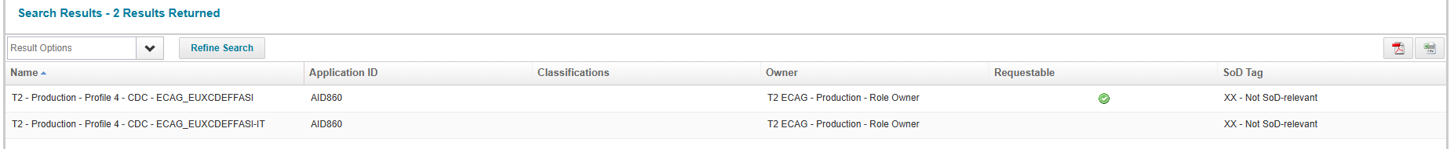

No final Digitized Authorization Concept, status 31.10.2025 , screenshot Nexis DAC:
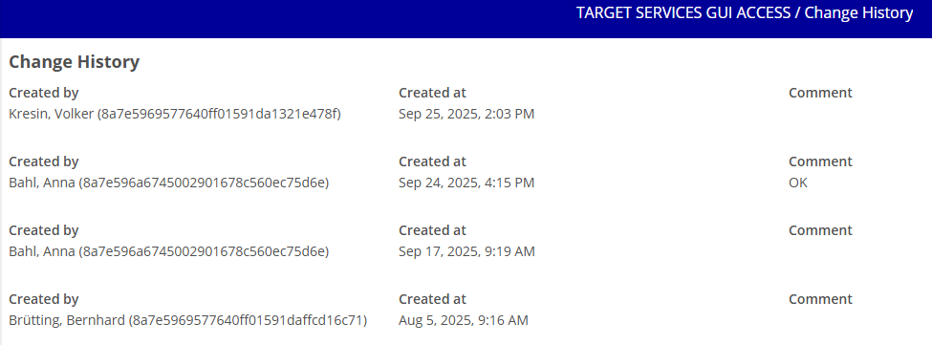

Related tickets/ Risks:
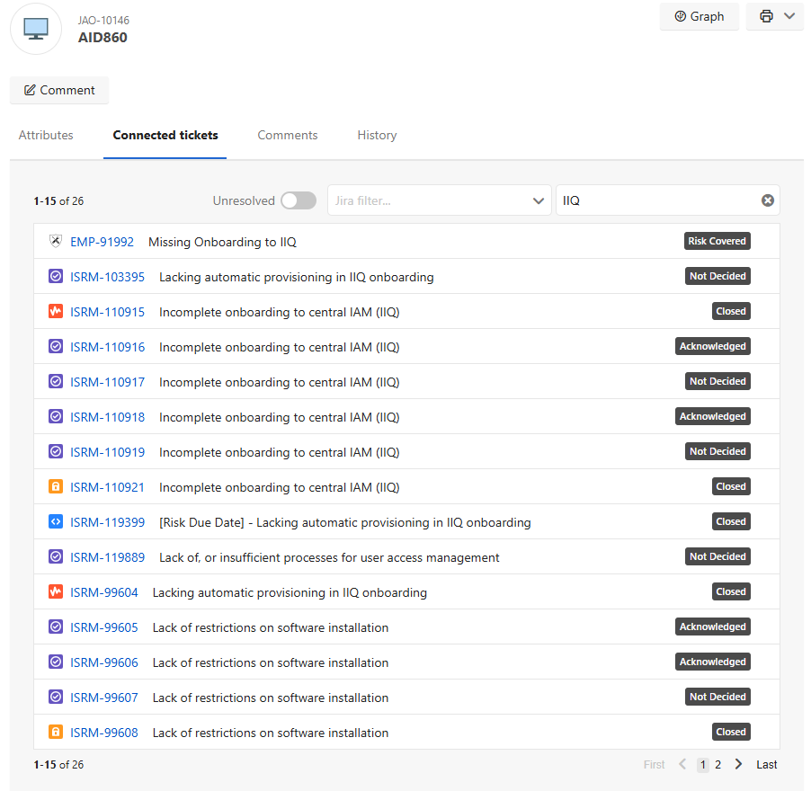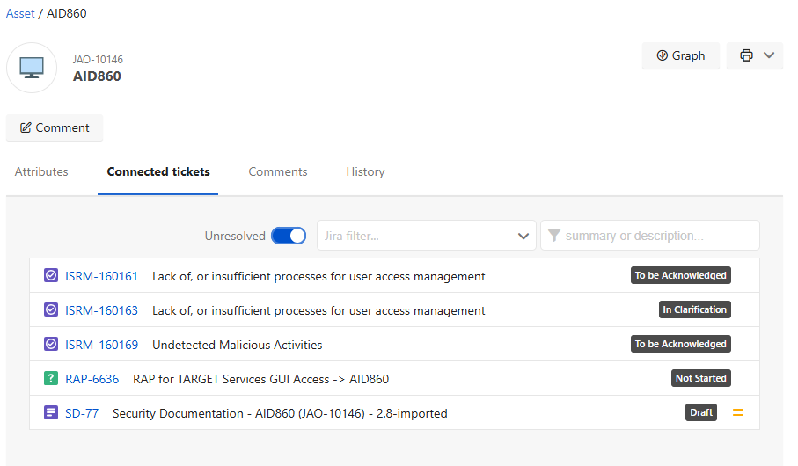

T7 (AID011) sample
Application Owner Ulrich Meyer
Application Owner Deputy Sergej Teverovski (not in DB Group anymore!)
Technical Information Security Officer Hans-Christian Weirich
Technical Information Security Officer Deputy Helge Harren
Digitized Security Documentation: approved
Digitized Authorization Concept: in development
Roles in Application marked as “critical” NO
(e.g. T7 - PRODUCTION - EEXLZ - EEXLZ - EEX MS OPERATIONS ROLE-IT)
Onboarding Status IIA in APMS: Manually Onboarded with Recon

No final Digitized Authorization Concept, status 31.10.2025 , screenshot Nexis DAC:
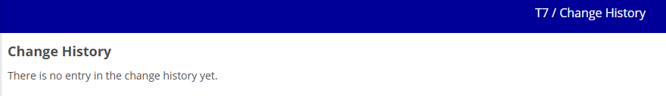
No change history available.

Related tickets/ Risks:
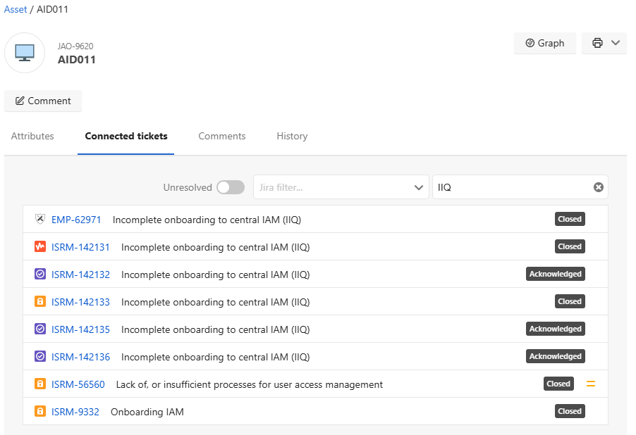

C7 SCS (AID596) sample
Application Owner Srinivas Garidepally
Application Owner Deputy Abhishek Bhatia
Technical Information Security Officer Alexander Buschmann
Technical Information Security Officer Deputy Nicolas Lindner
Digitized Security Documentation: draft
Digitized Authorization Concept: in development
Roles in Application marked as “critical” NO
(e.g. C7 - Production - ECAG - SCS SFR Clearing Operations)
Onboarding Status IIA in APMS: Manually Onboarded with Recon
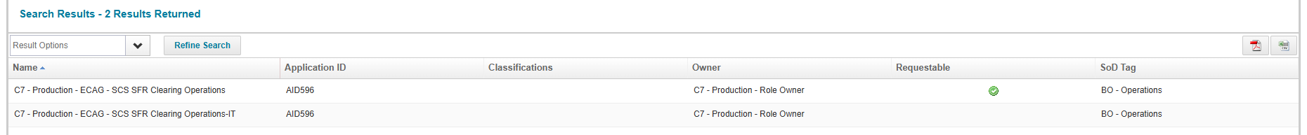
(e.g. C7 - Production - ECAG - SCS SFR Clearing Reference Data-IT)

No final Digitized Authorization Concept, status 31.10.2025 , screenshot Nexis DAC:
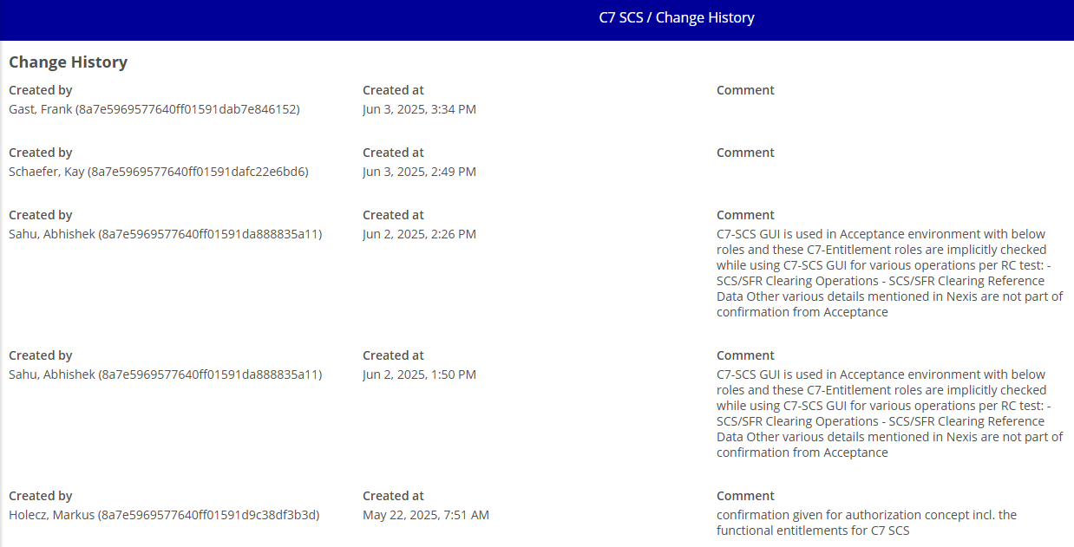

Related tickets/ Risks:
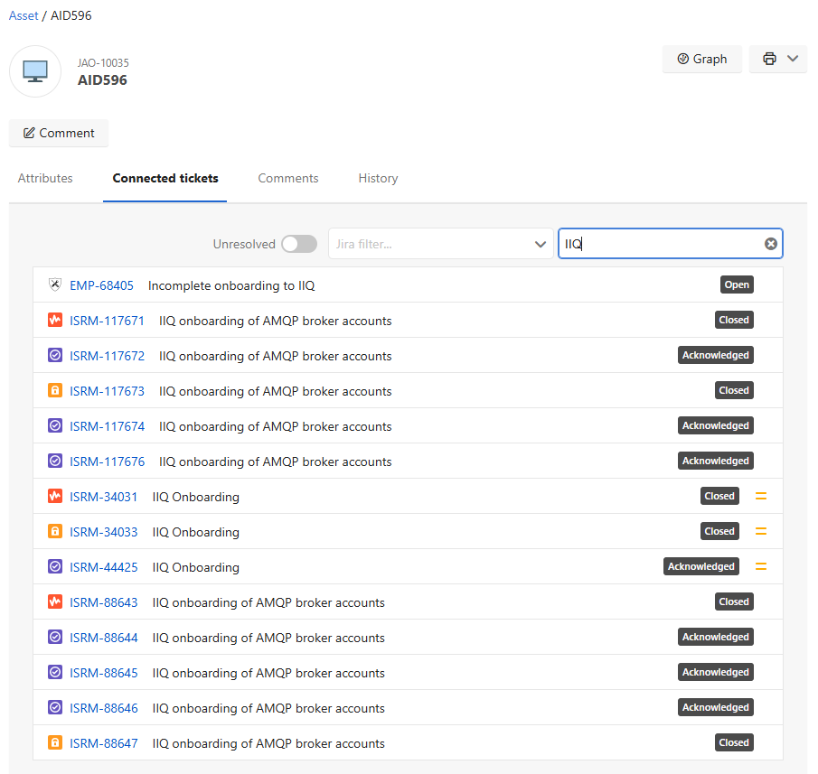
Bottomline Message Manager (AID1032) sample
Application Owner Mike Hartmann
Application Owner Deputy Matthias Harrer
Application Owner Deputy Falk Haase
Technical Information Security Officer Sudhir Dhawan
Technical Information Security Officer Deputy Jan-Tecker Gayen
Technical Information Security Officer Deputy Maria Rehberger
Digitized Security Documentation: draft
Digitized Authorization Concept: in development
Roles in Application marked as “critical” NO
(e.g. ECC Bottomline Message Manager Sharepoint - Production - Application Owner Work Group-IT)
Onboarding Status IIA in APMS: Manually Onboarded with Recon
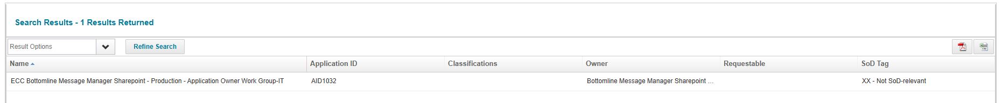

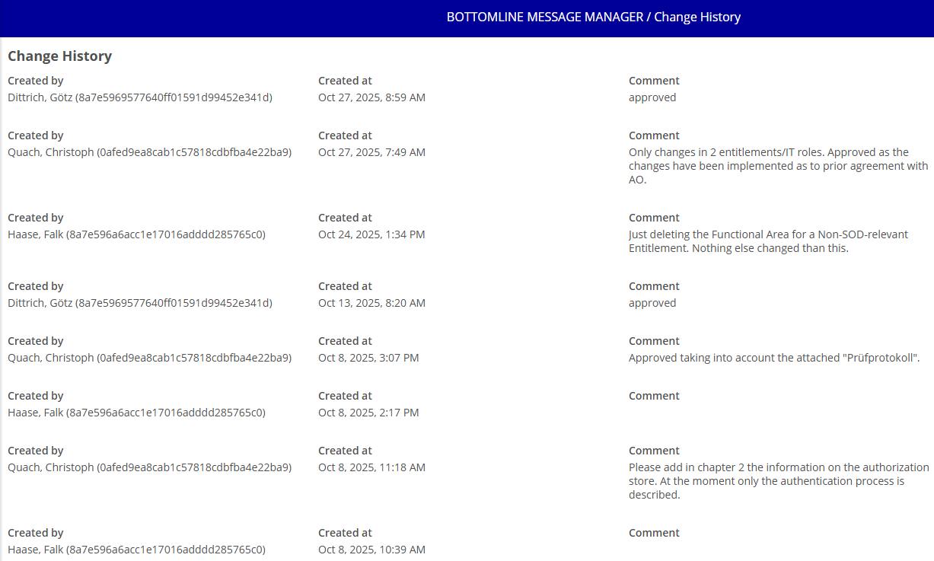

Additional testing on AID1032:
Risks regarding onboarding were continuously raised, acknowledged and closed.
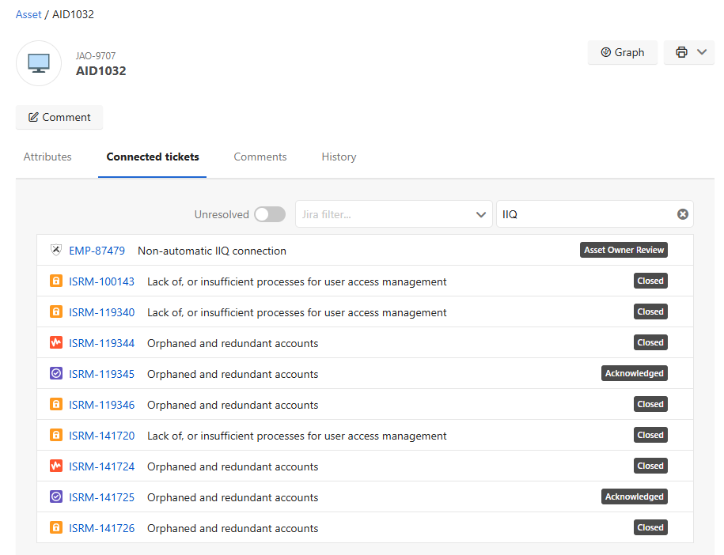

TP1.XX Outcome/ Conclusion
The sample-testing demonstrated the following:
- Applications, which were selected as CIF-relevant, did not automatically select all (business)-roles as critical
- The non-selection of (business) roles were in many cases done by applicants which were manually onboarded.
- Therefore a risk could exist relating to non-critical selections, onboarding-status and the importance/ CIF-relevance of the application.

To be considered in the outcome and importance of the criticality.

Outcome/ Conclusion TP1
IA noted that an oversight and controlling over compliance of recertification was not performed.
In particular the labeling of roles and entitlements were inconsistent – which relates to the definition, control execution and reporting/ oversight.
In particular the criticality, which triggers the half-annual recertification, was incorrectly handled and inconsistent.

Closeout described HERE
Draft title: Inconsistent Definition and Usage of Label ‘critical’

The general risks of an incomplete, incorrect or uncontrolled recertification and access review process may lead to unauthorized access, violation of Segregation of Duties (SoD) and least privilege principle, as well as insider threats (e.g. data theft, sabotage, misuse of privileges).

TP2: Oversight IIQ Onboarding
L2 or L3 or tests name: AU-121-05-CSDR Identity and Access Management (IAM), focus: recertification
Legal entities in scope: DBAG/CBL/ECAG/CBF/CH/LuxCSD/CS/CI/CFCL/ExR/EFAG

Test IIQ-onboarding, on-prem and cloud (follow up FuN 241106111950, reference to #2023-043_F11).
- Oversight and reporting of non-IIQ-onboarded applications (on-prem and cloud)
- Test the oversight, control and reporting, if systems are onboarded (on-prem and cloud)
- Verify if onboarding oversight includes information on reconciliation
- Manual- or automated information flows from and to IIQ (focusing on recertification).

Related risks, ref BCA:
An incomplete, incorrect or uncontrolled recertification process may lead to the following risks:
- Unauthorized access
- Regulatory incompliance
- Violation of Segregation of Duties (SoD), and least privilege principle
- Issues with data integrity
- Insider threats (e.g. data theft, sabotage, misuse of privileges).

Related FuN #241106111950:
IT Core Process Design & Operations (ÜPÜ) set up a new ITAM control for a solution to facilitate 2LoD oversight of IAM controls for IT assets not onboarded to IIQ.
Please find this control attached, including an overview of all ITAM controls. The control has version 1.1. However, ÜPÜ performed the OE test with control version 1.0.
It has to be checked if IT Core Process Design & Operations (ÜPÜ) also performs ITAM-042 for the updated version of the control. Test can only start in April 2025 as this control is aligned with the biannual recertification date. For details see:
https://deutscheboerse.sharepoint.com/:f:/r/sites/GIA/audits/2023%20Audits/2023-043%20IAM%20and%20PAM/13%20Follow-up/2023-043_F11-A03?csf=1&web=1&e=9wxheo
#241106111950, Volker Scheer

TP2.1: Oversight and reporting of non-IIQ-onboarded applications (on-prem and cloud)
Question on amount how the amount of applications (page 63, GRC slide) and actions on onboarded and not onboarded Infrastructure Assets per product line (page 66, GRC slide) remain open.

Testing:
The current GRC-slides focus on IIQ-onboarding only (IIQ Application onboarding, IIQ Infrastructure onboarding). A deeper analysis of non-IIQ-onboarded applications (on-prem and cloud) is not performed.

Meeting:
To: Frank Ackermann; Carsten Kreuz; Aamir Maliyakal; Stephan Hampel; Florian Laudensack
Subject: 2025-067 IAM and PAM // walkthrough open questions
When: Donnerstag, 9. Oktober 2025 13:00-13:55

In the meeting it was stated, that the underlying numbers in the monthly GRC reporting come from APMS/ CMS. This is why the numbers change each month (new applications coming, others are to be decommissioned, …) .

In general the CMS/ APMS entries are for Cloud and on-prem applications.
The status must be updated by the Application Owner.
The GRC reporting and oversight is given for Cloud- and on prem applications.
Risks related to not-onboarded applications are overseen by ICA.

TP2.1 Outcome/ Conclusion
The oversight on onboarded on-prem and cloud-applications is performed based on APMS/CMS information. The information and update are on the Application Owner only.
The underlying criteria to monitor IIQ-onboarding are not defined (e.g. target-ration: at least 97% of the operated business applications are IIQ-onboarded).
The tracking of risks related to IIQ onboarding exists, but it’s weak due to there is no control related to.

Observation / for the finding:
- Reported onboarding information in DSC-slides rely on correct CMS information
- Target rate and completeness statement varies from month to month (depending on information in CMS)
- Criteria to monitor and report on IIQ-onboarding not defined
- Related or raised risks and exception-tickets regarding IIQ-onboarding not managed, summarized and reported
- Cluster-risk (x% of applications not onboarded, y% of applications only manually onboarded) not comprehensively analyzed and reported.

TP2.2: Test the oversight, control and reporting, if systems are onboarded (on-prem and cloud)
Testing:
The information, if an application is onboarded and in which state, is updated by the Application Owner into CMS/ APMS.

1. ITAM-042:
The current IT-control (ITAM-042) verifies, if this information is stored and field “APPL: Onboarded to IIQ” is not empty. The latest ITAM-042 procedure is stored HERE.
The control is performed by 1LoD IT Core Process Governance (U).

If the information field is empty, an IT Internal Ticket is opened for the Application Owner to request the following information:
- Reason for not being onboarded for IIQ
- Authorization concept
- Last recertification of roles
- Last recertification of users

IA received details from IT Core Process Governance (U), that the control was performed. EVIDENCE
Application Owners of not onboarded systems were informed, and a ticket was raised.

Additionally onboarding (manual) was tested between APMS and CMS.
OUTCOME
The deviations between the views had its reason in the requested CMS/CRM-rights.

The test is performed based on information stored in CMS.
!!! To search and see all information fields in SAP CRM/ CMS, the following right must be set: !!!
P50CLNT010\ZS:SRV000_READ_USER
and in parallel
all SRV000_<LE-ShortName> must be removed.

Additional testings were on unknown onboarding status between APMS and information managed and stored by the IAM-team. OUTCOME-of-TEST

2. Meeting on Onboarding information
Information on control and oversight was followed by a meeting.
In the meeting, the deviations were explained:
To: Frank Ackermann; Sean Mc Taggart; Carsten Kreuz; Milos Medrik
Cc: Srinivas Rampalli; Shravankumar Mohankumar; Maciej Przybylski; Stephan Hampel; Aamir Maliyakal; Miglena Kuder; Oliver Bonk
Subject: 2025-067 IAM and PAM // Information and controls reg. onboarding status
When: Donnerstag, 23. Oktober 2025 09:00-09:55
- IAM-team performs technical testing, if user-information were managed and tested per application.
- Based on return, onboarding status is stored in IAM-owned database/ data sink.
- If deviations to, or the onboarding status is poor, the IAM-team request information from the Application Owner for a raised ticket in ISCRA (IS Risk Management) or an EMP-ticket (Exception Management process).
- Both information is stored in the IAM-managed database/ Excel, but not shared with CMS and visa-versa.

With regards to the ITAM-042 control, evidence were received (Email and evidence reply (email: Fr 03.10.2025 16:49) ).
The performed controls raised a LIST OF TICKETS without proper onboarding information, as well a STRONG CONCERN (email: RE ITAM-042 Control) regarding the status.

Testing – all tickets raised with ITAM-042 checked against current APMS entries:

APPL: Application Code | APPL: Product Descr. | PF: Appl. Owner | Ticket
AID2176 | DAISY – AI Platform | Michal Preuss | 21529342
AID2199 | CORA | Dirk Richter | 21529343
AID2212 | Apple AppStore | Markus Buschky | 21529344
AID2004 | Energy Kahoot | Pavan Kumar Sataluru | 21529345
AID2208 | DeepL | Martin Krnac | 21529346
AID2211 | Google PlayStore | Markus Buschky | 21529344

Result of Test:
For 1 out of 6 tickets the status was still unknown.

While testing, in APMS/CMS 31 operational applications were with unknown IIQ-onboarding status.

TP2.2 Outcome/ Conclusion
- Onboarding Data in CMS relies on information, send with interface from IIQ to CMS
- IT Controls rely on data in CMS
- Onboarding ration and reporting (e.g. in DSC) rely on data in APMS
- IA identified that data is not transferred from IIQ to APMS and therefore the data is not correct.
- Therefore, reporting and controls on onboarding information are likely not correct.

Examples of historical and closed findings, which relate to CMS data quality:
Data quality KPIs not regularly updated 2022-075_F02 S2
Incorrect onboarding status reporting of cloud assets in CMS 2024-057_F02 S2

As of this aspect is also addressed in IT AMELI, and the organization is setting up the successor of CMS (Project ATLAS, INTRANET) this deviations and observations are not raised as a finding.

TP2.3: Verify if onboarding oversight includes information on reconciliation
Testing:
Export of APMS/ CMS and verification of onboarding-status over time (current CMS export vs 2024 CMS export).
Testing on the onboarding status, information which were exchanged and controls related.

Comparison between APMS, CMS and information ICA (U) displayed a not matching oversight.
Two compared information were share with the auditees, in particular on the onboarding status “unknown” and “manual”.

In combination with the onboarding testing and oversight, Information on control were requested, email Fr 26.09.2025 15:33 2025-067 IAM and PAM // Oversight IIQ Onboarding, performed ITAM-042 control

In the meeting, the deviations were explained:
To: Frank Ackermann; Sean Mc Taggart; Carsten Kreuz; Milos Medrik
Cc: Srinivas Rampalli; Shravankumar Mohankumar; Maciej Przybylski; Stephan Hampel; Aamir Maliyakal; Miglena Kuder; Oliver Bonk
Subject: 2025-067 IAM and PAM // Information and controls reg. onboarding status
When: Donnerstag, 23. Oktober 2025 09:00-09:55
- IAM-team performs technical testing, if user-information were managed and tested per application.
- Based on return, onboarding status is stored in IAM-database.
- If deviations to, or the onboarding status is poor, the IAM-team request information from the Application Owner for a raised ticket in ISCRA (IS Risk Management) or an EMP-ticket (Exception Management process)
- Both information is stored in the IAM-managed database/ Excel, but not shared with CMS and visa-versa.
- In the meeting is was explained, that IAM (here IIQ) transmits onboarding information to CMS. IIQ is the master. In the discussed example it became obvious and was committed by the IAM-team, that the installed interface between IIQ and CMS did not work correctly – and therefore CMS/ AMPS did not display correctly the onboarding status.

The onboarding status was displayed in the DSC.
The DSC-slides are stored in the BCA-preparation-folder.
Information or KPIs on reconciliation of access-rights and role-verification are not integrated in the DSC.
The Onboarding status meters against the latest APMS-onboarding information. As of APMS-information were updated frequently, the metering onboarding/not onboarded was volatile.

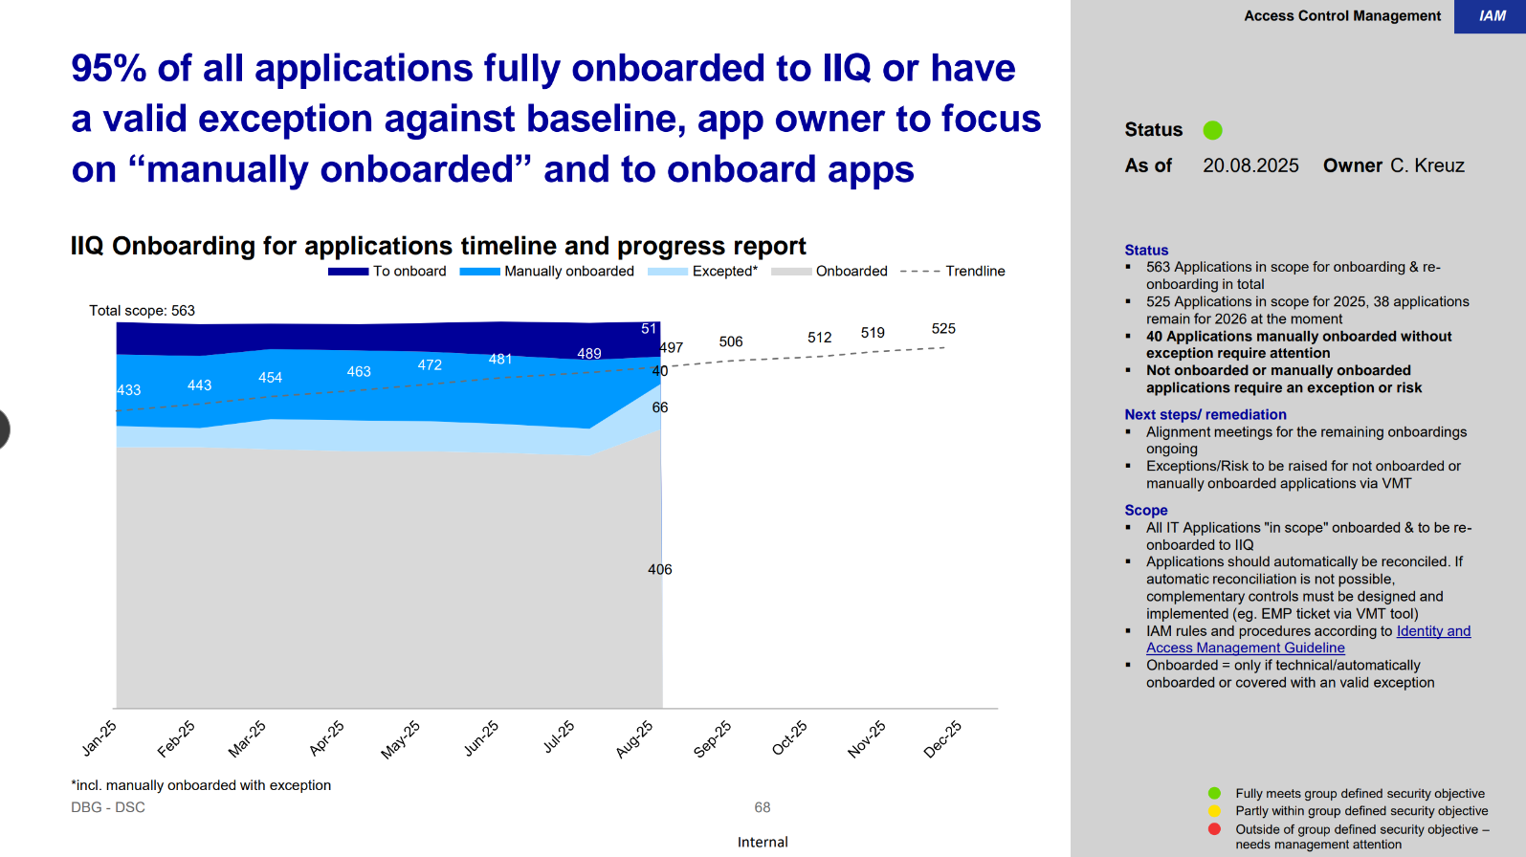

Remark:
In the timeframe of the audit, no company demand was addressed that the onboarding oversight and reporting must be combined with an overview of reconciliation.
Besides that – also the manual provisioning includes reconciliation.
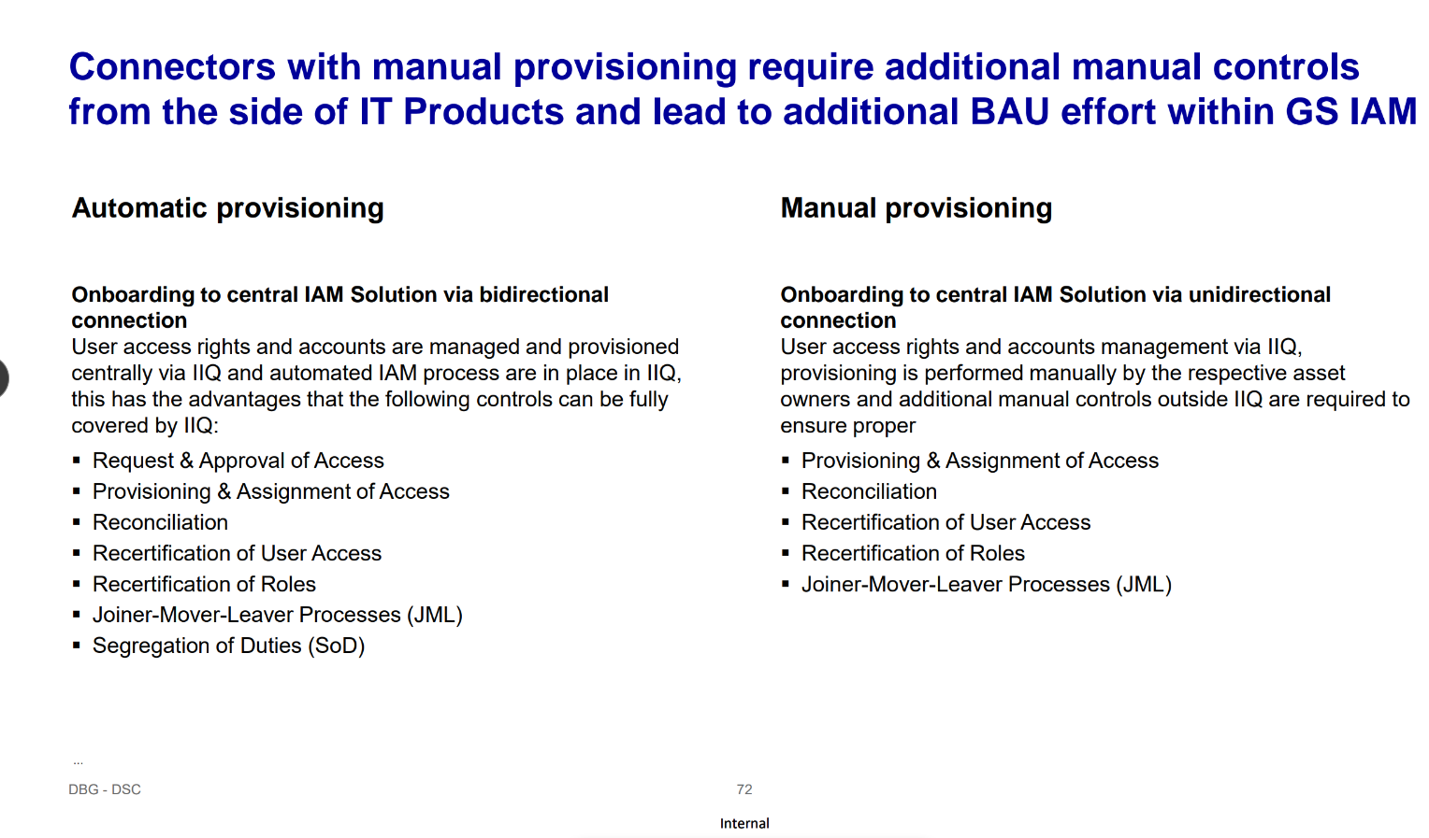

TP2.3 Outcome/ Conclusion
No deviations or observations were noted from IA in course of the testing.

TP2.4: Manual- or automated information flows from and to IIQ (focusing on recertification)
Testing:
Out of the exchanges and interviews.

Meeting:
To: Frank Ackermann; Sean Mc Taggart; Carsten Kreuz; Milos Medrik
Cc: Srinivas Rampalli; Shravankumar Mohankumar; Maciej Przybylski; Stephan Hampel; Aamir Maliyakal; Miglena Kuder; Oliver Bonk
Subject: 2025-067 IAM and PAM // Information and controls reg. onboarding status
When: Donnerstag, 23. Oktober 2025 09:00-09:55

- In the meeting it was discussed, that IIQ, Nexis and CMS information may be out of sync
- This would have an effect on controls and reportings; e.g. on onboarding.
- While discussing the status, that information on unknown onboarding status was discussed (EVIDENCE)
- The IAM-team stated, that IIQ has an interface to CMS that shadows the onboarding information into CMS; and this seems not to be working.
- After the meeting the IAM team shared the record structure of information in Nexis, as well as the Specification for the Dig. Authorization Concept.
- There are interfaces between IIQ and Nexis (bidirectional), and IIQ and CMS (bidirectional).

- The recertification of users (line manager approval) are performed in IIQ. The recertification of roles (e.g. birthrights, business roles) are performed in Nexis.
- IIQ stores, manages and “reports” recertification-details on users-recertification (e.g. line manager reporting).
- Nexis stores, manages and “reports” the recertification of business-roles.

Independent on the information flow:
In APMS/ CMS are different onboarding status marked. An explicit definition of the status and a clarification on how to handle and manage similar tags, such as ‘manual onboarded’ and ‘Manually Onboarded’ is not set.

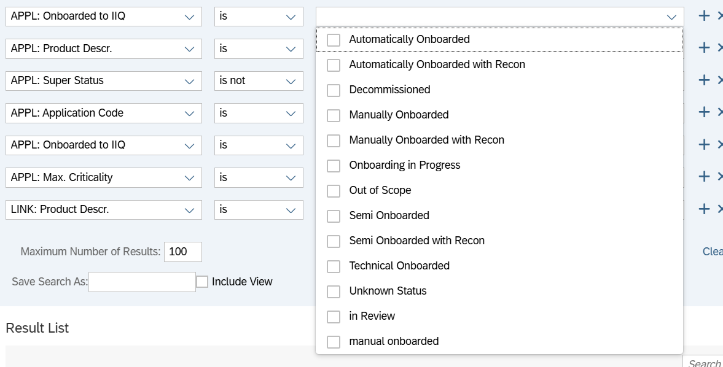

Additionally – related risks and exceptions are manually kept and entered by the IAM-team.
- While discussing the status, that information on unknown onboarding status was discussed (EVIDENCE)
In the meeting it was stated that during the onboarding process, the Application Owner is asked, if a risk was raised (when not onboarded). This information is then held by the IAM team; but the core risk information and management is with IS Risk Management (U) .

TP2.4 Outcome/ Conclusion
Information on Onboarding should be stored in CMS (master data). IA testing revealed missing consistency between IIQ/ Nexis and CMS, due to the not working IIQ-CMS connector.
Additionally controls and management of risks (applications not being onboarded to IIQ) are distributed in Group Security. An overview and comprehensive management or risks and exceptions in combination with the onboarding (and recertification) is not possible and established yet.

Observation / for the finding:
- Reported onboarding information in DSC-slides relies on correct CMS information
- In time of the fieldwork the interface between IIQ and CMS did not reliably work (deviations discussed in meeting; CMS onboarding unknown vs IAM-team infos including risk/exception details). The automatic information flow was not working.
- An comprehensive Risks and Exceptions oversight was not generated. References were made that this is a task to IS Risk Management.

Outcome/ Conclusion TP2
The following observations were already shared with the IAM team (email Fr 24.10.2025 14:56)
- IIQ-onboarding information are stored in APMS/ CMS but also in a separate list/ excel spreadsheet by Identity & Access Management (U) – which is not synchronized.
- The correctness of imported onboarding information from APMS/ CMS is not reverified by Identity & Access Management (U).
- Not or incomplete IIQ-onboarding of applications require a managed risk or managed exception.
- Information on managed risks or exceptions are not integrated into Nexis (e.g. for the DAC).
- Identity & Access Management (U) does not perform controls or tests, if managed risks or exceptions were raised, documented, and managed.
- The IT asset integration/connection types are ranked from “best case” to “worst case”. (Identity and Access Management Procedure, 4.11.3.2.1. IT asset integration/connection types)
- The connection ranking is not directly related to the IIQ-onboarding information in APMS/ CMS.
- Ranked connections with “Third Best Case” to “Worst Case” do not automatically request to raise, document, and manage a risk.

Summary of all observations regarding the IIQ onboarding oversight (for closeout point):
Deficiencies in Data Integrity and Consistency
- Information on IIQ-onboarding was not correctly transferred from the Identity and Access Management (IIQ) system to the central inventory (CMS). As the interface was not reliable at the time of the audit, the application-specific IIQ-onboarding information was not completely correct.
- Information from CMS was used as underlying in Group Securities Digital Security Committee KPIs reporting
- As of the identified deficiencies in the CMS-data, the “IIQ Onboarding for applications timeline and progress report” and “IIQ Application Onboarding status per IT Product” KPI in the DSC-report cannot be assured which may impact decisions related to this data.
- IT/ ITAM-controls validated only, if the information-field on onboarding was filled (not empty).

Undefined Onboarding Status and Criteria
- A standardized taxonomy for classifying IIQ onboarding statuses has not been established. This includes the definition, control criteria as well as related risks.
- According to the IAM Procedure, the IT asset integration/ connection types are ranked from “best case” to “worst case”. The connection ranking was not directly related to the IIQ-onboarding information in CMS.
- Subsequent relations or controls regarding the relationship between the IT asset integration/ connection types, IIQ-onboarding information and the requirement to document a risk or an exception, were not defined.

Inadequate Monitoring and Risk Management
Due to the undefined onboarding status and criteria as well as deficiencies in the CMS-data
- consequent monitoring and a correct oversight over IIQ onboarding
- controls and IS/ICT risk management regarding IIQ onboarding
was not ensured.
Additionally, risks and exception tickets related to the IIQ onboarding were not being systematically managed, aggregated, or reported.
This results in a lack of transparency and an inability to address systemic issues in the onboarding and related risks, such as that regular access-reviews for manual onboarded applications were not transparently overseen. For example, the cluster-risk over all applications not being automatedly onboarded or account information were not reconciled, was not assessed and reported.

Lack of Comprehensive Risk Oversight
The responsibility for managing risks (not being IIQ onboarded) has been deflected to IS Risk Management, indicating a siloed approach regarding related risks.
The responsibility for managing exceptions (not being IIQ onboarded) has been deflected to Group Security LE Governance, indicating a siloed approach regarding related exceptions.
A comprehensive oversight on risks related to the IIQ onboarding was not developed by now.

The control operating effectiveness is assessed as not sufficient,
1 item identified and included in the close-out list. Closeout described HERE

TP3: Recertification of SharePoint
L2 or L3 or tests name: AU-121-05-CSDR Identity and Access Management (IAM), focus: recertification
Legal entities in scope: DBAG/CBL/ECAG/CBF/CH/LuxCSD/CS/CI/CFCL/ExR/EFAG

TP3: Audit recertification of SharePoint access and accounts outside DBG domain accounts (follow up FuN 241106112230, reference to #2025-024_F03).
- Test, how Sharepoint- and outside DBG domain accounts are defined and controlled, according to 1LoD and 2LoD documentation.
- Verify the management of and reporting over these accounts.

Related risks, ref BCA:
An incomplete, incorrect or uncontrolled recertification process may lead to the following risks:
- Unauthorized access
- Regulatory incompliance
- Violation of Segregation of Duties (SoD), and least privilege principle
- Issues with data integrity
- Insider threats (e.g. data theft, sabotage, misuse of privileges).

Related FuN #241106112230
Central oversight over user access recertification for IT applications and SharePoint sites not onboarded to IIQ
See below for details:
https://deutscheboerse.sharepoint.com/:f:/r/sites/GIA/audits/2023%20Audits/2023-043%20IAM%20and%20PAM/13%20Follow-up/2023-043_F11-A03?csf=1&web=1&e=9wxheo
It has to checked, if Corporate IT has set up a sustainable control regarding the recertification of access rights for SharePoint.
241106112230, Volker Scheer

LINK to evidence (stated in FuN)

Indirekt related IA-finding #2025-024_F03
Lack of recertification for birthright roles, due: 10 November 2025, Identity and Access Management (ICA)

The relation of this testing and the finding is weak.
Access to Sharepoint is given based on UserID/ Windows ID, not on birthrights.

TP3.1 Test, how Sharepoint- and outside DBG domain accounts are defined and controlled, according to 1LoD and 2LoD documentation.

Testing:
To perform the testing, two meetings with the responsible 1st LoD was performed by IA.

In the first meeting
To: Frank Ackermann; Benoit Krier; Dean Halligan
Subject: 2025-067 IAM and PAM // SharePoint recertification
When: Montag, 15. September 2025 16:00-16:25
the Sharepoint recertification was discussed.

- Sharepoint-Accounts are managed outside of IIQ and are done by the team Microsoft 365 Operations (U) .
- Brief intro over Sharepoint access controls and sendout of “recertification” checks.
- Currently no confirmation of Sharepoint review by Owner
- Revision of Recertification Process, see Audit 2023-043_F11 IAM/PAM - Recertification of SharePoint access
- It is planned to reshape the recertification in combination with a Powertool, Sharepoint and the specific approval of information by the Owner (Review performed etc).
- Sharepoint is ONLY allowing access for internal and EXT (e.g. contracters with a DBG ID) accounts. External accounts (e.g. customer accounts with external email accounts) do and cannot have access.
- To share information with external accounts, solutions like Brainloop are offered.
- The current draft was send as information:
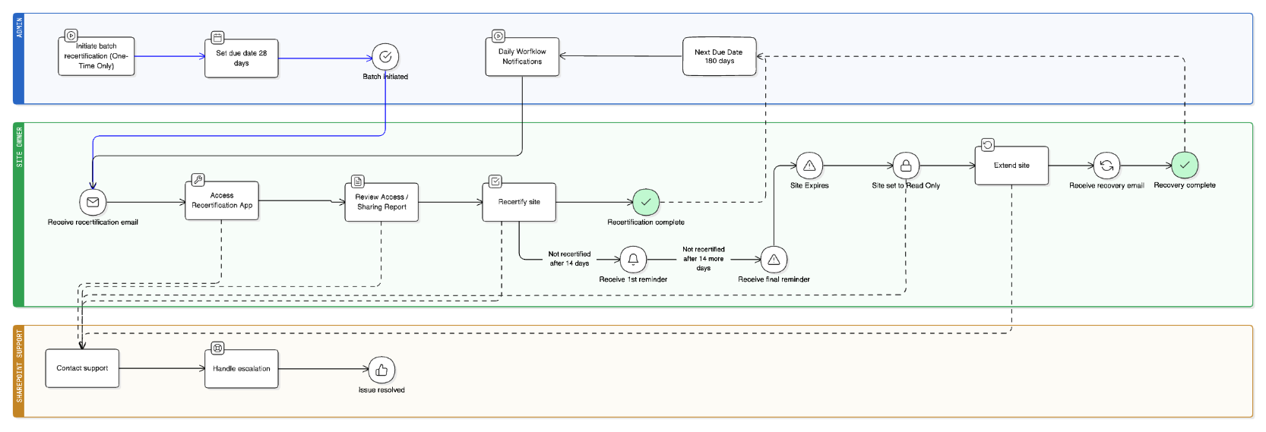

A second meeting was performed:
To: Frank Ackermann; Dean Halligan
Cc: Milos Medrik; Yezad Wadia; Srinivas Rampalli; Shravankumar Mohankumar; CRP-Audit; Benoit Krier; Pengcheng Chen; Aniket Deshpande
Subject: 2025-067 IAM and PAM // SharePoint recertification, exchange II
When: Mittwoch, 15. Oktober 2025 15:00-15:25

In the meeting the audit-log files, the control, verification of the Sharepoint Owners review and the identification of information-classification of files were discussed.

After the meeting, an extract of the Sharepoint Recertification was send: evidence.

Underlying:
Identity and Access Management Guideline, V1.1 15.08.2025:
ID: 3 (version 1.1) Segregation of Duties
Segregation of Duties (SoD) must be defined, applied, and controlled to prevent any unauthorized access to sensitive data, circumventing access controls or conflicting business interests.

ID: 5 (version 1.1) Access Control
Access controls must be defined, implemented, monitored and controlled to prevent any unauthorized access, avoid breach of access controls and restrict access to support the protection requirements considering each level of classification.

ID: 15 (version 1.1) Recertification
The recertification of access rights and role compositions must be defined, integrated in the access procedure, monitored and controlled.

On Mo 20.10.2025 17:19 (email) IA shared the following observations:
- The recertification process and the related control (for Sharepoint Access review) is currently in revision. It is planned to finalize the new workflow ca mid Q4/2025.
- It is planned that the new workflow increases the audit log (access change log).
- A content-analysis in combination with an information labelling check would overrun the file-crawler and block the system.
- The access review will remain on UID (per person), not on roles (e.g. birthright roles).
- Audit logs must be separately extracted. As of now it is not planned to generate an audit view to extract log-files and access-reports for dedicated roles (e.g. auditor read-only view).
- In our sample-testing we verified 30 Sharepoint-access-reports (used for the last recertification and a current extract). We tested for orphaned accounts and internal movers (change of responsibilities).
Only 4 of the 30 samples did not display any deficiency. For 26 of the 30 sampled access reports at least one orphaned account, inactive EXT-account (contractor) or internal mover (who should not have access right anymore) was identified. The deviations include Sharepoint Owners as well as Users.
This indicates that the recertification is most likely performed by the Sharepoint Owners as a rubberstamp approval (select all, approve; or approve w/o detailed access check).

TP3.1 Outcome/ Conclusion
The half-annual control is currently under revision.
IA noted, that the controls and the latter review/ revocation of access rights to Sharepoint is incomplete.

TP3.2 Verify the management of and reporting over these accounts.
Testing:
In both meetings (see TP3.1), specific oversight management and reporting were not described and did not exist.

Sharepoint Owners are requested to perform the recertification. This is a control and workflow managed and supported by the Sharepoint-tool.
For this, reports are generated to support the Sharepoint Owner in the review and re-approval process.

30 report samples are analyzed and stored.
Result: see also stated in observation shared with the auditee in TP3.1 .
Deviations are identified, see TP3-test orphaned accounts.

Additionally, IA tested the audit logs (as supplementing evidence of a review).
Out of 3 selected audit logs 2 were available. One logfile could not be provided by the system.
The audit-logs are not easy to read and to verify, see TP3 log samples.

TP3.2 Outcome/ Conclusion
As of now, a specific oversight management and reporting was not existing.
In course of the further exchange on the finding (to revise the Sharepoint access control), the reporting will pointed out as additional proposal for a recommendation.

Outcome/ Conclusion TP3
- The definition of criteria and the control for Sharepoint-access is not existent in a way which supports proper 1LoD and 2LoD control execution
- The current control in revision and is not well documented
- Testing had not reference with IA finding #2025-024_F03 because birthrights are not considered in accessing Sharepoint
- The performed recertification and access review (including with several deviations and unrevoked orphaned accounts) may stand for generic and unverified approvals (“rubberstamp approvals”).

The control operating effectiveness is assessed as not sufficient,
1 item identified and included in the close-out list. Closeout described HERE

The general risks of an incomplete, incorrect or uncontrolled recertification and access review process may lead to unauthorized access, violation of Segregation of Duties (SoD) and least privilege principle, as well as insider threats (e.g. data theft, sabotage, misuse of privileges).

TP5: Assess recertification of centralized business roles in Nexis
L2 or L3 or tests name: AU-121-05-CSDR Identity and Access Management (IAM), focus: recertification
Legal entities in scope: DBAG/CBL/ECAG/CBF/CH/LuxCSD/CS/CI/CFCL/ExR/EFAG

TP5: Assess recertification of centralized business roles in Nexis, carried out in 2025.
(ref. L2 AU-110-11-Business Roles)

TP5: Assess recertification of centralized business roles in Nexis, carried out in 2025 (ref. L2 AU-110-11-Business Roles)
- Test the definition and controls of business roles recertification in 1LoD and 2LoD documents
- Verify, based on examples, if controls were performed and reported.

Proposal for sample-testing, ref. FuN 250306153041 (see testing PAM implementation):
Check the April 2025 IIQ recertification campaign for CyberArk C safe access groups

Related risks, ref BCA:
An incomplete, incorrect or uncontrolled recertification process may lead to the following risks:
- Unauthorized access
- Regulatory incompliance
- Violation of Segregation of Duties (SoD), and least privilege principle
- Issues with data integrity
- Insider threats (e.g. data theft, sabotage, misuse of privileges).

TP 5.1 Test the definition and controls of business roles recertification in 1LoD and 2LoD documents
Testing:
Role descriptions:
Business Roles are designed and described in the document
Business Role Methodology, V1.0, 24 Mai 2023 LINK
(complete document)

Control descriptions:
1LoD: Identity and Access Management Procedure, V1.0, 30.06.2025 LINK
Chapter 4.11.2.3. Recertification describes the general recertification process.
Chapter 3.1.12. Recertification – ID 15 describes the controls of the 1LoD controls.
Requirement “15.1.1 User access recertification must take place every 6 months for business-critical access and for privileged access of all levels by the responsible Line Manager and respective Role Owners.” is considered on page 43.
Requirement “15.1.2 User access recertification must take place every 12 months for all other accesses by the
responsible Line Manager.” is considered on page 43.

TP5.1 Outcome/ Conclusion
The controls are in general described.
Specific control-criteria (e.g. at least 95% of business roles must be recertified in time x) were not defined. (Remark: no underlying for this requirement in the 2LoD Guideline/ Standard).

TP 5.2 Verify, based on examples, if controls were performed and reported.
Testing:
In Nexis IAM (Analytics) it can be identified, if a (business) role is a birthright role.
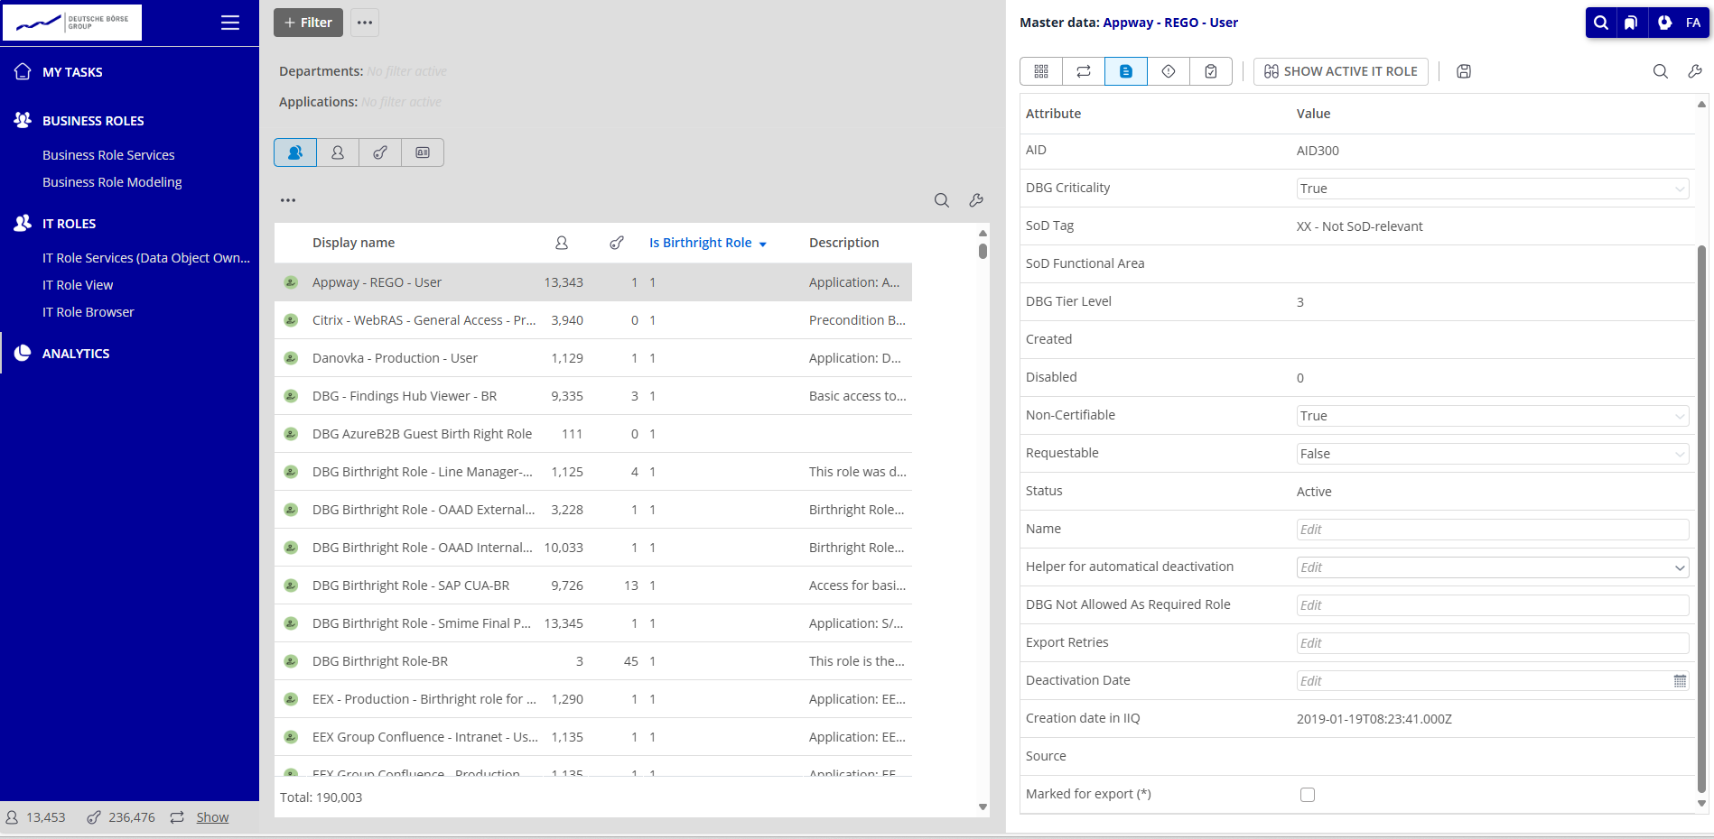

The reconfirmation / changes can be identified, including timestamp:
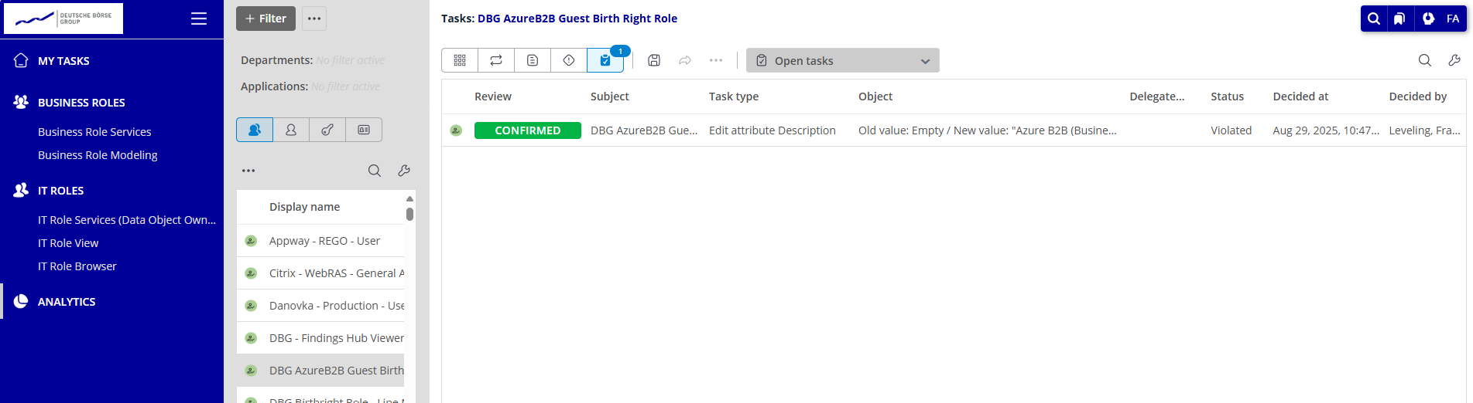

Same applies to Business Roles:
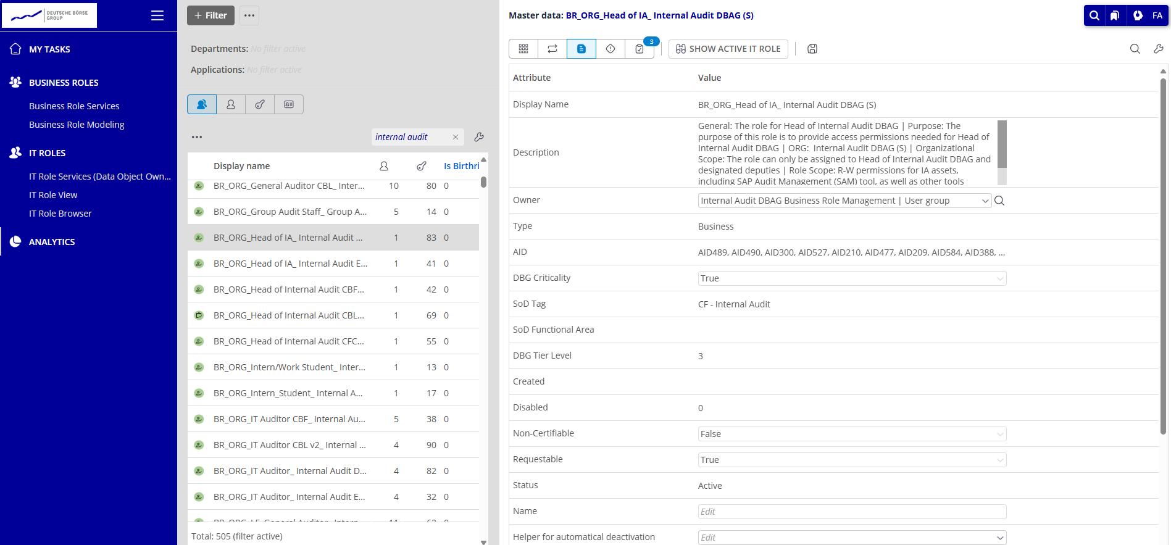

And corresponding changes and updates:
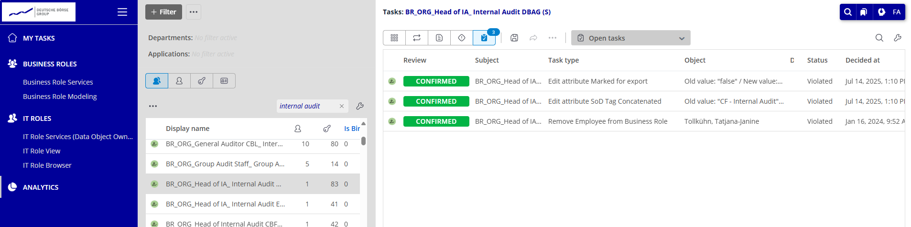

Additionally (see evidence stored for TP6):

In course of closing the fieldwork additional evidence was provided, that the
Business Roles are in recertification:
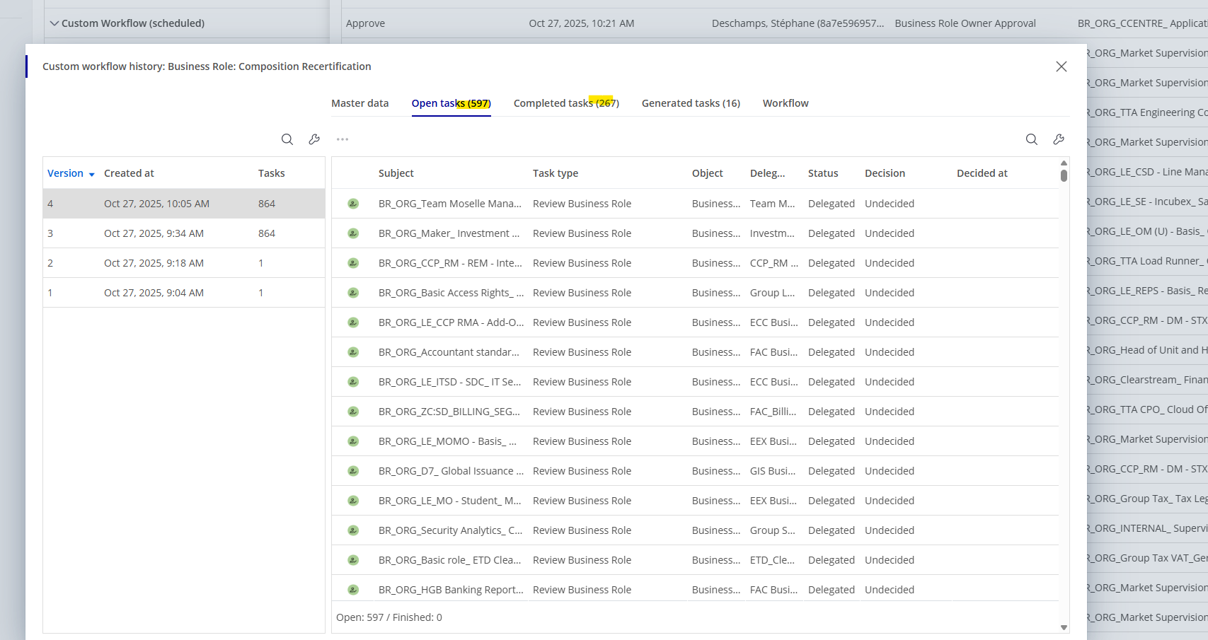

And the Birthright Roles were checked:
See FOLDER

TP5.2 Outcome/ Conclusion
IA overseen the test/ control activity on business- and birthright-roles.
No deviation were identified in the timeframe of the fieldwork and audit.

Outcome/ Conclusion TP5
No deviation were identified in the timeframe of the fieldwork and audit.
Control definition were existing.
1LoD controls were defined.
1LoD controls were performed and the recertification (for the current half of the year) was ongoing.
The control operating effectiveness is assessed as sufficient.

TP6: Audit oversight and recertification for birthright roles
L2 or L3 or tests name: AU-121-05-CSDR Identity and Access Management (IAM), focus: recertification
Legal entities in scope: DBAG/CBL/ECAG/CBF/CH/LuxCSD/CS/CI/CFCL/ExR/EFAG

If applicable and not overlapping with ongoing remediation:
TP6: Audit the oversight and recertification for birthright roles (reference to #2025-024_F03).
- Verify definition, demands and controls in 1LoD and 2LoD documents
- Analyze identification, oversight, reconciliation and reporting on birthright roles.

Related risks, ref BCA:
An incomplete, incorrect or uncontrolled recertification process may lead to the following risks:
- Unauthorized access
- Regulatory incompliance
- Violation of Segregation of Duties (SoD), and least privilege principle
- Issues with data integrity
- Insider threats (e.g. data theft, sabotage, misuse of privileges).

2025-024_F03-A01 Lack of recertification for birthright roles

TP6.1 Verify definition, demands and controls in 1LoD and 2LoD documents
Underlying for testing:
2LoD: Identity and Access Management Guideline Version, V1.1, 15.08.2025 LINK
15.1.3 The following types of recertification must be performed and documented: Role composition recertification by the Role Owner and Asset Owner must take place every 12 months and must include birth right roles. (ref. DORA RTS RMF A.21.1e.iv), ISO/IEC 27001:2022 A.5.18)

Testing:
The current guideline considers the birth right role recertification.
The Identity and Access Management Procedure, V1.0 30.06.2025, reflects this company demand.
In the time of the audit/ fieldwork, the recertification H2/2025 was initiated (INTRANET).
The closure of the finding / birthright recertification is in development.

TP6.1 Outcome/ Conclusion
No observations/ deviation.

TP6.2 Analyze identification, oversight, reconciliation and reporting on birthright roles.
Testing:
Birthright roles are about to be integrated in the standard process. This was articulated also in IA finding
# 2025-024_F03-A01 Lack of recertification for birthright roles.

The finding was closed.
REF SAP SAM
Action plan for closure (evidences)

According to Identity & Access Management (U) the next recertification wave (which includes birthrights) is planned to start end of October 2025.

Within Nexis IA the birthright and business recertification could be verified per linked entitlement.
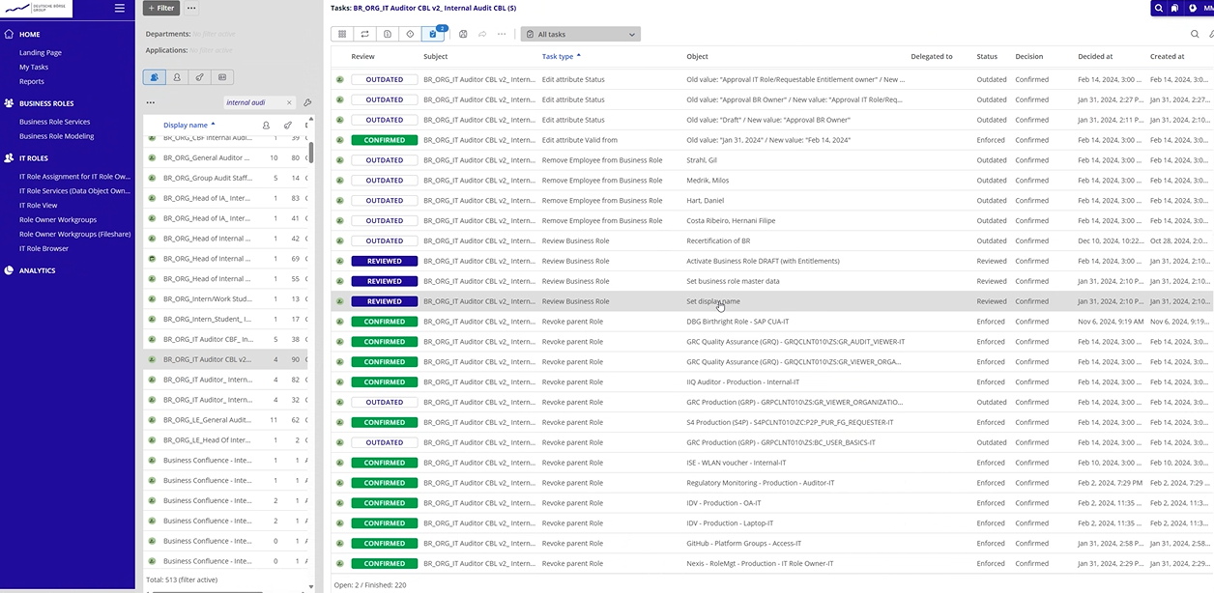

TP6.2 Outcome/ Conclusion
No observations/ deviation.

Outcome/ Conclusion TP6
The finding was closed in time and evidence uploaded in SAP SAM.
The birthright recertification will be included in the general recertification process/ waves. Birthrights and Business Roles (BR) will be handled the same way (recertification pushed in waves.)
An overview of performed controls and recertification is not well set and developed. Many evidence needs to be extracted per user or entitlement; or with support from the IAM expert team (considered in TP1).

In Course of closing the fieldwork additional evidence was provided, that the
Business Roles are in recertification:

And the Birthright Roles were checked:
See FOLDER

The control operating effectiveness is assessed as sufficient.
FuNs were re-verified and can be closed.

AI usage
The audit steps and the workpaper development have been supported by the following AI prompts and responses.

IAM recertification – key risks

Prompt: IAM recertification – key risks
Temperature: 0 - precise

Persona:
You are an experienced Cyber Security Expert and Senior IT Auditor.

Context:
You are auditing the following area and process: IAM and PAM, focusing on IAM-recertification.
The company you are auditing is a regulated European financial institution and must comply to European regulation DORA, MaRisk and CSSF.

Task:
Create a list of top 7 key risks on IAM-recertification.
Describe in senior management language (such as for CIO, CEO, CFO, COO).
Add reference by listing the specific European regulation and article.
If possible, add information on likelihood and impact of identified risks.

Format:
List as text.
Limit the response to bullet points.
Limit to 300 words.

Response
"Rubber-Stamping" of Access Rights (and Inadequate Reviews)
Business managers may approve their team's access permissions without diligent review, leading to excessive user privileges that are not aligned with job responsibilities. This increases the risk of internal fraud and data breaches.
Regulation: DORA, Article 9; MaRisk AT 7.2; CSSF Circular 20/750 Section 4.3.1.
Likelihood: High / Impact: High

Untimely Removal of Access for Leavers
Delays in revoking access for former employees or contractors create "orphaned accounts," which are prime targets for unauthorized access to sensitive financial data and systems.
Regulation: DORA, Article 9(4); MaRisk AT 7.2; CSSF Circular 20/750 Section 4.3.1.
Likelihood: Medium / Impact: High

Privilege Creep
Employees accumulate access rights as they change roles within the company, but obsolete permissions are not removed. This gradual accumulation of excessive privileges heightens the risk of unauthorized actions and complicates audit trails.
Regulation: DORA, Article 9(4); MaRisk AT 7.2; CSSF Circular 20/750 Section 4.3.1.
Likelihood: High / Impact: Medium

Inadequate Segregation of Duties (SoD)
The recertification process fails to identify and correct toxic combinations of access rights, such as a single user having the ability to both create and approve payments, which significantly increases the risk of financial fraud.
Regulation: MaRisk AT 7.2; CSSF Circular 20/750 Section 4.3.2.
Likelihood: Medium / Impact: High

Lack of Clear Ownership and Accountability
When it is unclear who is responsible for reviewing and approving specific access rights (e.g., IT vs. business), the process becomes ineffective, leading to unreviewed permissions and security gaps.
Regulation: DORA, Article 5; MaRisk AT 4.3.1.
Likelihood: High / Impact: Medium

Insufficient Audit Trails
The failure to properly document who reviewed, approved, and rejected access, and when, makes it impossible to prove compliance to auditors and regulators, potentially resulting in findings and penalties.
Regulation: DORA, Article 9(5); MaRisk AT 7.2; CSSF Circular 20/750 Section 4.3.1.
Likelihood: High / Impact: Medium

Over-Privileged Technical and Service Accounts
Non-human accounts used by applications and systems often have excessive, unmonitored permissions. If compromised, these accounts can provide attackers with broad access to critical infrastructure and data.
Regulation: DORA, Article 9; MaRisk AT 7.2.
Likelihood: Medium / Impact: High

-----

Result of separate prompt:
Incomplete Scope of Recertification
The recertification process fails to cover all critical systems, applications, and privileged access. This oversight is a medium-likelihood risk with a very high impact, as it can leave significant security gaps. DORA requires a comprehensive ICT risk management framework that covers all critical assets.

Manual and Error-Prone Processes
Using manual methods like spreadsheets for recertification is inefficient and susceptible to human error, leading to inaccuracies and delays. The likelihood of errors is high, with a medium impact on operational efficiency and data integrity. MaRisk AT 7.2 encourages the use of system support to ensure efficient and controlled processes.

Inconsistent Recertification Cycles
Failure to conduct access reviews at regular, risk-defined intervals allows security gaps to persist. The likelihood is high without automated and enforced scheduling. The impact is significant, as it increases the window of opportunity for misuse of privileges. Regulations require periodic and risk-based reviews of access rights.

Inadequate Management of Third-Party Access
With increasing reliance on external ICT services, failing to rigorously recertify third-party vendor access poses a substantial risk. The likelihood is high due to complex supply chains. The impact is severe, as a breach through a third party can lead to significant data loss and reputational damage. DORA places a strong emphasis on managing ICT third-party risk.

Optimize/ Refine / Adjust closeout point

Prompt: Optimize/ Refine / Adjust closeout point
Temperature: 0 - precise

Persona:
You are an experienced Cyber Security Expert and Senior IT Auditor.

Context:
You are auditing the following area and process: IAM and PAM, focusing on IAM-recertification.
The company you are auditing is a regulated European financial institution and must comply to European regulation DORA, MaRisk and CSSF.

Target audience for this task:
Describe in senior management language (such as for CIO, CEO, CFO, COO).

Format:
List as text.
Limit to 500 words.
0
Task:
Optimize the following text
“..”

Response closeout point 1: Deficiencies in Sharepoint access, recertification and oversight
Executive Summary:
Our recent audit of Identity and Access Management (IAM) has identified significant control weaknesses in how we manage access to SharePoint. As SharePoint is used to store all classifications of data, including 'strictly confidential' information, these deficiencies expose the bank to a high risk of unauthorized access, data leakage, and potential insider threats. These conditions represent a clear deviation from the principles of least privilege and violate key requirements of European regulations including DORA, MaRisk, and CSSF.

Key Findings:
Our audit revealed that the current process for recertifying user access to SharePoint is ineffective and lacks independent oversight. The ongoing revision of the process is a positive step, but critical risks require immediate mitigation.
Specifically, we noted:
- Lack of a Formalized and Controlled Process: The access review and recertification process is currently in development and not yet finalized. This means there is no reliable, standardized control in place to ensure access rights are appropriate.
- Excessive and Inappropriate Access Rights: A review of access reports showed a significant number of "orphaned" accounts (belonging to former employees), inactive external accounts, and accounts of employees who have moved internally but retained unnecessary access. This accumulation of unneeded privileges significantly increases the risk of misuse.
- Inability to Effectively Audit or Monitor: Neither second nor third-line defense functions (2LoD and 3LoD) have direct access to the necessary audit logs to perform independent control activities. The logs that can be manually extracted do not allow for a historical analysis of who had access to specific data at a particular point in time, which is a critical capability for any forensic investigation and a regulatory expectation.
- Potential for "Rubber-Stamping" Approvals: Due to the lack of a robust process and clear reporting, there is a high risk that SharePoint owners are approving access rights without detailed verification. This renders the current review process largely ineffective as a control measure.

Business Impact and Regulatory Risk:
These findings are not merely technical issues; they represent a significant business and regulatory risk. An uncontrolled access environment directly contravenes the explicit requirements of DORA, MaRisk, and CSSF for robust ICT risk management, periodic access reviews, and the principle of least privilege. The identified weaknesses could lead to:
- Regulatory Penalties and Sanctions: Failure to comply with these regulations can result in significant fines and reputational damage.
- Data Breaches and Financial Loss: Unauthorized access to sensitive client or internal data could lead to data theft, fraud, or sabotage.
- Violation of Segregation of Duties (SoD): The lack of control over access rights may lead to toxic combinations of privileges, undermining a cornerstone of our internal control framework.
We urge senior management to prioritize the remediation of these control gaps to safeguard the bank's assets and ensure compliance with our regulatory obligations.

---

The outcome was considered in the closeout point before sharing with the auditees.

Response closeout point 2: Inconsistent Definition and Usage of Label ‘critical’
Our audit revealed that the "criticality" labels, which are fundamental to prioritizing the review of accounts and access rights, are inconsistently defined and applied. This has led to a situation where the system for classifying critical assets is unreliable, preventing a risk-based approach to access reviews.

Key issues for management attention include:
- Inconsistent and Undefined Criticality Labels: There is no clear, uniform definition for what constitutes a "critical" role, entitlement, or application across our core IAM systems. This ambiguity has resulted in a massive volume of roles being marked as critical without proper justification, while a significant number of entitlements lack any criticality rating at all. This directly impacts our ability to conduct timely and focused access reviews as required by regulations.
- Flawed Recertification Frequency: The frequency of access recertification—annually versus semi-annually—is determined by a "criticality" flag. However, with inconsistent labeling and a lack of clear ownership for this data, we cannot ensure that access to our most sensitive applications is being reviewed with the appropriate rigor and frequency.
- Lack of Automated Cross-Validation: The process for assigning criticality is manual and operates in silos. There are no automated checks to ensure that applications identified as critical from a business impact perspective are also treated as critical within our IAM systems. This disconnect means that accounts and roles with access to vital systems may not be subject to more stringent, semi-annual reviews.
- Significant Gaps in Mandatory Data: Many mandatory criticality fields remain empty. These gaps persist until the next annual review, leaving us exposed in the interim. This procedural weakness fails to meet the standards of robust ICT risk management frameworks mandated by DORA.

These deficiencies collectively weaken our control environment and create an unacceptable level of risk. An ineffective recertification process may lead to unauthorized access, data theft, and violations of the least privilege principle. This not only exposes us to potential financial loss and reputational damage but also places us at risk of regulatory penalties for non-compliance.

---

Remark: This response includes wrong summaries and hallucinations.

The outcome was considered in the closeout point before sharing with the auditees.

Response closeout point 3: Inconsistent Oversight and Management of IIQ Onboarding Information
Our findings indicate a fundamental breakdown in the data supply chain that underpins our entire IAM infrastructure. The core issues are:
- Compromised Data Integrity and Unreliable Reporting: The automated interface responsible for transferring data from our central identity management solution (IIQ) to the Configuration Management System (CMS) and the Application Portfolio Management System (APMS) is failing. This breakdown means that the data used for critical IT controls, risk assessments, and management reporting is inaccurate and unreliable. Consequently, our ability to demonstrate control effectiveness to regulators is severely weakened. Regulations like DORA and MaRisk mandate robust data management to ensure accuracy, completeness, and integrity.
- Ineffective Risk Management and Oversight: There is no defined process for monitoring the success of application onboarding into our IAM systems. Risks and exceptions related to onboarding failures are not being systematically managed, aggregated, or reported. This lack of oversight prevents us from understanding our true risk posture, particularly the "cluster risk" of having a significant percentage of applications managed manually or not at all. This directly contravenes risk management principles outlined in DORA and MaRisk, which require institutions to identify and manage all sources of ICT risks.
- Increased Exposure to Cyber Threats and Insider Risk: When applications are not properly onboarded into our automated IAM systems, user access is often managed manually. This leads to inconsistent access controls, delays in revoking access for terminated employees, and a higher risk of excessive privileges. These gaps create significant vulnerabilities that could be exploited by internal or external actors, leading to data breaches and financial loss. Effective IAM is a cornerstone of cybersecurity and a key requirement for protecting customer data under regulations like DORA.
- Regulatory Non-Compliance and Financial Penalties: The combination of poor data quality, inadequate risk oversight, and weak access controls places the institution at high risk of failing regulatory audits. European regulations such as DORA, MaRisk, and CSSF circulars on IT and data management are stringent, and non-compliance can lead to substantial fines, reputational damage, and mandated remedial actions that are often costly and disruptive.
In conclusion, the issues identified are not merely operational inconveniences; they represent a significant threat to the security, integrity, and regulatory compliance of our institution. We must act decisively to rectify these data and process deficiencies to safeguard our assets and maintain the trust of our clients and regulators.

---

Remark: This response includes wrong summaries and hallucinations.

The outcome was considered in the closeout point before sharing with the auditees.

Template

Work Done:
Control Design Effectiveness
- review XXX.

Internal Audit (IA) reviewed xxxx.

ISSUE (1): XXX. (different color to be used)

Results:
The control design is assessed as …
1 item identified and included in the close-out list.

Work Done:
Control Operating Effectiveness
2. Review XXX.

Internal Audit (IA) reviewed xxxx.

ISSUE (2): XXX. (different color to be used)

Results:
The control operating effectiveness is assessed as…
1 item identified and included in the close-out list.

